**Convert ISO images to docker images**

[#sofianehamlaoui](https://dev.to/t/sofianehamlaoui)[#dockerimage](https://dev.to/t/dockerimage)[#converting](https://dev.to/t/converting)[#iso](https://dev.to/t/iso)

**🐳 Convert ISO images to docker images**

Yep! I was looking for a method or a trick to convert ISO files to docker images, It was hard to find one ! But the only one was not really explained and lacking some information. So here we are !!

**Choosing the ISO file :**

Well before starting the process ! Keep in mind that you have to use a [***live disc***](https://en.wikipedia.org/wiki/Live_CD) ***,*** means a bootable version of the operating system.

**Before Starting ! :**

In this tutorial/story, I’ll use Ubuntu 18.04.3 [LTS](https://en.wikipedia.org/wiki/Long-term_support)’s live disc ISO,

**Keywords :**

* ***rootfs*** : a [file system](https://en.wikipedia.org/wiki/File_system). In [Linux](https://en.wikipedia.org/wiki/Linux), all file systems have a mount point, which is the directory where the mounted file system connects to the root file system
* ***squashfs :*** a [compressed](https://en.wikipedia.org/wiki/Data_compression) read-only [file system](https://en.wikipedia.org/wiki/File_system) for [Linux](https://en.wikipedia.org/wiki/Linux)
* ***unsquashfs :*** a tool to [uncompress](https://en.wikipedia.org/wiki/Data_compression) squashfs [file systems](https://en.wikipedia.org/wiki/File_system)

**Requirments :**

* ***squashfs-tools :*** install [squashfs-tools](https://www.tldp.org/HOWTO/html_single/SquashFS-HOWTO/) in your system
* Downlading the LiveCD ISO version

[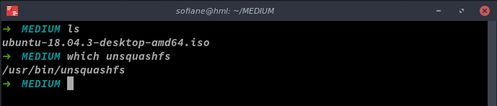](https://res.cloudinary.com/practicaldev/image/fetch/s--md1CvpKV--/c_limit%2Cf_auto%2Cfl_progressive%2Cq_auto%2Cw_880/https:/cdn-images-1.medium.com/max/689/1%2A5iKRJRqEauoShmFeUK0CEg.png)ISO file downloaded & squashfs-tools installed

**Let’s start ! :**

***1- Start by creating the 2 folders (rootfs and unsquashfs)***

$: mkdir rootfs unquashfs

[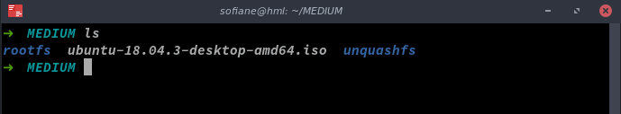](https://res.cloudinary.com/practicaldev/image/fetch/s--SeV9Whes--/c_limit%2Cf_auto%2Cfl_progressive%2Cq_auto%2Cw_880/https:/cdn-images-1.medium.com/max/689/1%2ANURaMl8Ci4YwdiiQtStmOw.png)Creating rootfs & unsquashfs folders

***2- mount your ISO file to the rootfs folder as a loop device***

$: sudo mount -o loop ubuntu-18.04.3-desktop-amd64.iso rootfs

[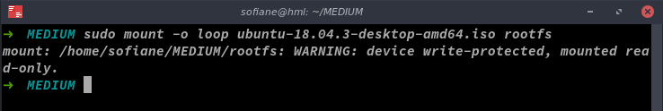](https://res.cloudinary.com/practicaldev/image/fetch/s--QsjX3UnK--/c_limit%2Cf_auto%2Cfl_progressive%2Cq_auto%2Cw_880/https:/cdn-images-1.medium.com/max/738/1%2ATsYCriGIdOADKWutnvevNA.png)Mounting the ISO file

***3- Find the filesystem.squashfs file***

$: find . -type f | grep filesystem.squashfs

[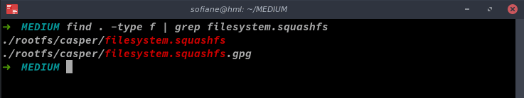](https://res.cloudinary.com/practicaldev/image/fetch/s--ccHfPt3---/c_limit%2Cf_auto%2Cfl_progressive%2Cq_auto%2Cw_880/https:/cdn-images-1.medium.com/max/737/1%2A-E1VJCkjliKF50-yftzmhg.png)Finding the filesystem.squashfs file

***4- use unsquashfs to extract filesystem files to the unsquashfs folder (that would take between 5–10mins)***

$: sudo unsquashfs -f -d unsquashfs/ rootfs/casper/filesystem.squashfs

[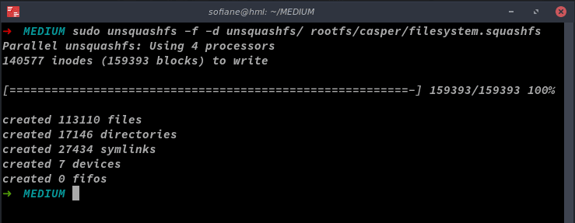](https://res.cloudinary.com/practicaldev/image/fetch/s--VIFReI-8--/c_limit%2Cf_auto%2Cfl_progressive%2Cq_auto%2Cw_880/https:/cdn-images-1.medium.com/max/739/1%2A1VvqdeBDYCkPLqe5IhQ4HA.png)Extractingthe filesystem files to the unsquashfs folder

***5- compress and import the image using docker (that would take some time 10–20 mins)***

$: sudo tar -C unsquashfs -c . | docker import - sofiane/myimg

***6- you will get a sha256 hash (somthing like this )***

$:sha256:qf917d58831f926c6b93ff84bd6az68550a6cd6c36aeb6c837c53d655d9453sh

[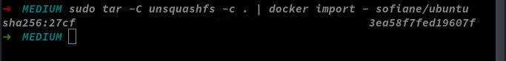](https://res.cloudinary.com/practicaldev/image/fetch/s--h-5tocy9--/c_limit%2Cf_auto%2Cfl_progressive%2Cq_auto%2Cw_880/https:/cdn-images-1.medium.com/max/683/1%2AQi0hAgYD_Z1ZbpQdYKcAcA.jpeg)***Compressing then importing the image using docker***

***7- test your docker image :***

$:docker run -h ubuntu -i -t sofiane/myimg bash

[](https://res.cloudinary.com/practicaldev/image/fetch/s--rGNtxNQR--/c_limit%2Cf_auto%2Cfl_progressive%2Cq_auto%2Cw_880/https:/cdn-images-1.medium.com/max/965/1%2AZRWqyHmN1z8ivdzJLKr7zA.png)Docker images

[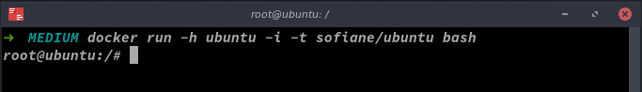](https://res.cloudinary.com/practicaldev/image/fetch/s--xHyrG3iE--/c_limit%2Cf_auto%2Cfl_progressive%2Cq_auto%2Cw_880/https:/cdn-images-1.medium.com/max/683/1%2Axe0m7QiM-0c-XBl3oizNtw.png)Your docker image is READY!